horizontal line

# Project Report

Language Translator

By

# Devanshu Rakesh Soni

SY.MCA

**JSPM's Jayawantrao Sawant College of Engineering, Hadapsar**

**{MCA Department, JSCOE}**

**AFFILIATED TO**

**SAVITRIBAI PHULE PUNE UNIVERSITY**

# ABSTRACT

*“Translation is the communication of the meaning of a source-language text by means of an equivalent target-language text. The English language draws a terminological distinction (which does not exist in every language) between translating (a written text) and interpreting (oral or signed communication between users of different languages)”—Wiki*

A competent translator is not only bilingual but bicultural. A language is not merely a collection of words and of rules of grammar and syntax for generating sentences, but also a vast interconnecting system of connotations and cultural references.

A language translator application can be an easy go-to tool to provide translations to multiple languages for a given text format. Presently, many of such applications that exist can provide results to all text, audio sources. One of many applications, Google Translator is most popular, is capable of converting source text into required language. This application also aims for a similar approach to provide translations.

# INTRODUCTION

A Translator is an online application that translates any sentence or phrase or word into the targeted language. Translation apps are fairly important in daily life especially when you travel abroad. They help people communicate without a human translator or spending months learning a language.

In recent days, trending technologies such as Artificial Intelligence, ML Linguistic Models and so on are vibrant. That’s probably making the Smartphone users look for smarter apps which makes their life simple. A Translator supports text translation in many, up to 108 language variations. We can use it every day for business, travel, and education.

## Project Quality Model

1. **Correctness**⇒Aim to provide an expert translation system, to text-based input, into required language translated text.
2. **Accessible**⇒Available on request. Mobility and Responsiveness.
3. **Reliability**⇒Support as many languages as possible to provide translations.
4. **Usability**⇒User-friendly and summarized.
5. **Flexibility**⇒Replacing human interaction with one-to-many service agent, ondemand.
6. **Portability**⇒System is ported to a desktop application.
7. **Efficiency**⇒Uses framework for consistency and integrity.

# EXISTING METHOD

# **Competent translators show the following attributes:**

* A very good knowledge of the language, written and spoken, from which they are translating (the source language);
* An excellent command of the language into which they are translating (the target language);
* Familiarity with the subject matter of the text being translated;
* A profound understanding of the etymological and idiomatic correlates between the two languages, including sociolinguistic register when appropriate; and
* A finely tuned sense of when to metaphrase ("translate literally") and when to paraphrase, so as to assure true rather than spurious equivalents between the source and target language texts.

1. Interpreting is the facilitation of oral or sign-language communication, either simultaneously or consecutively, between two, or among three or more, speakers who are not speaking, or signing, the same language. Many of such professional Interpreters are hired to translate oral/text based, manually with their expertise of being multilinguistic.
2. Person invests in multilingual skill development to provide users with their needs at the cost of the time and efforts enclosed to learn and understand the required sets of languages by this interpreter. As this existing method of consulting such personnel would only be one of the options to complete a task.
3. Other DIY solutions would suggest a published copy of notes that help with interpretation tasks that users may have to pursue on their own, risking the spurious equivalents between the source and target language texts.
4. Online consultancy and guidance can achieve thorough Forum and personal web sites to answer grievances but they fail to be as fast as the current options.

# PROPOSED METHOD WITH ARCHITECTURE

1. User connects with the system via the internet and submits a query.
2. Proposed system can automate the interpretation process of text-based translation.
3. System would keep track of all the present variantes of required languages for future queries and instant translation requirements.
4. Aims to process queries faster and quicker response.
5. Reliability, as the system refers to an ever expanding linguistic database via API.

## 

## Architecture:

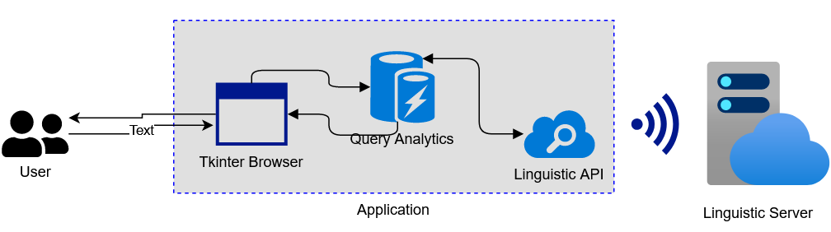

*For Standalone application*

*For web application.*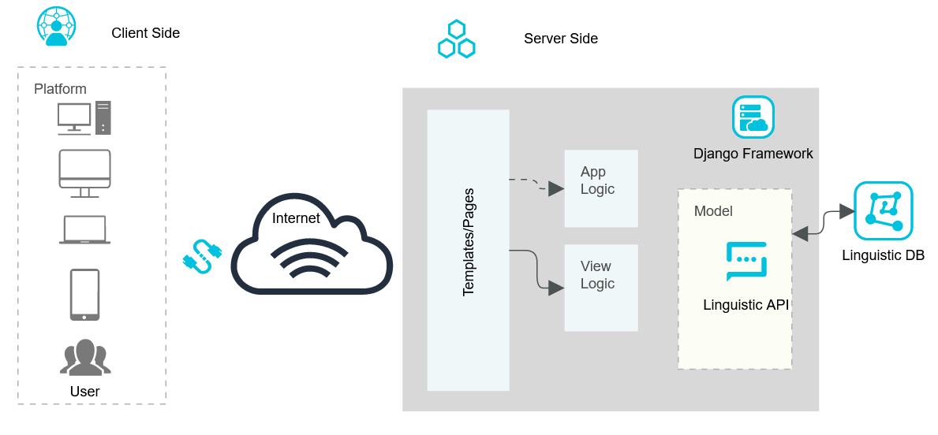

## 

## Methodology:

**Technologies :**

* Front - End:
  + Bootstrap v4 (min css, min js)
  + Javascript
  + Jinja
* Back - End:
  + Django (Python Framework) py3.8.1
  + google-trans-new API version 1.1.9 (*python* tools for google translate *api)*
* Standalone Desktop application:
  + Python 3.8.1
  + Tkinter
  + google-trans-new API

**IMPLEMENTATION**

Django Framework(MVT):

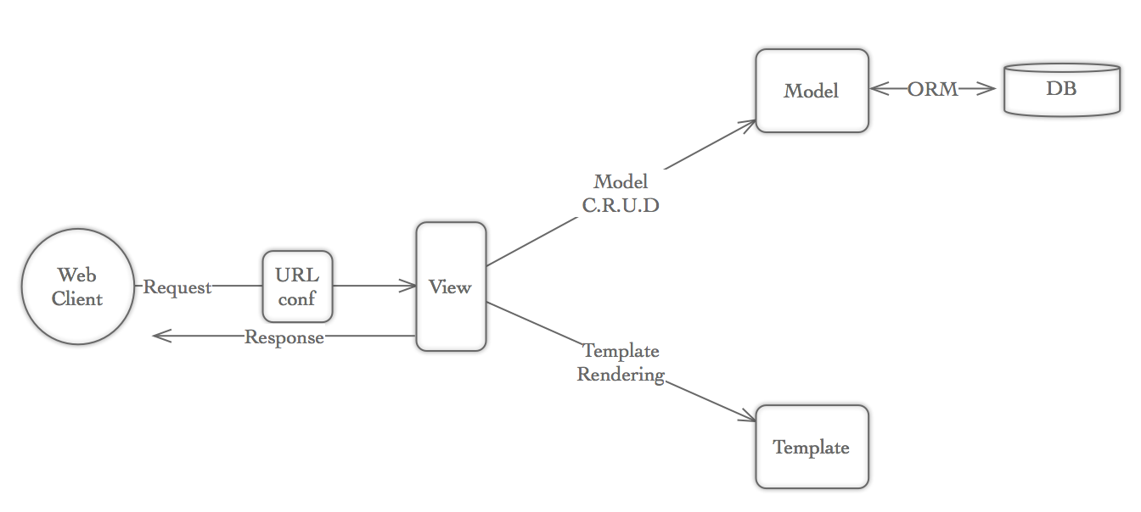

* Django framework provides all the server side handling resources and database connectivity.
* External linguistic API is used to send requests to google translator linguistic servers to process the request.
* Bootstrap 4 CDN used to develop front-end Templates to get user queries. Jinja used to insert content dynamically.
* Request is handled by Views, forwarded the data schema from Models, to provide integrity.
* *For desktop application,* a similar translator API is utilized to process the queries and provide results.

**CONCLUSION**

## Scope of proposed system:

Language translator application aims to provide easy access to linguative services to end users with system requirements as:

* A device with internet connection with a web browser app to access the web application. Specified:
  1. Smartphone
  2. Desktop system
  3. Laptop.
* For standalone application, device with internet connectivity:
  1. Laptop
  2. Desktop

## Need of Computerization:

The existing manual system is particularly manual and requires expert supervision to complete the task.

TIme consuming and availability issues. Inconsistency with accuracy and conceptual integrity.

Results are not available at the moment and require guidance and feedback from users at each step.